Double Precision vs Single Precision

Streamwbise velocity $u$ is stored in single precision and double precision respectively.

First and second derivatives $f$ are computed using 4th, 6th or 8th finite different scheme (FD4 / FD6 / FD8), where $f$ could be ${∂u}/{∂x}$, ${∂^{2}u}/{∂y^{2}}$, etc.

The values with single precision are denoted with subscription “*s*”, while the values with double precision are denoted with subscription “*d*” (e.g. $f_{s}$ and $f_{d}$)

*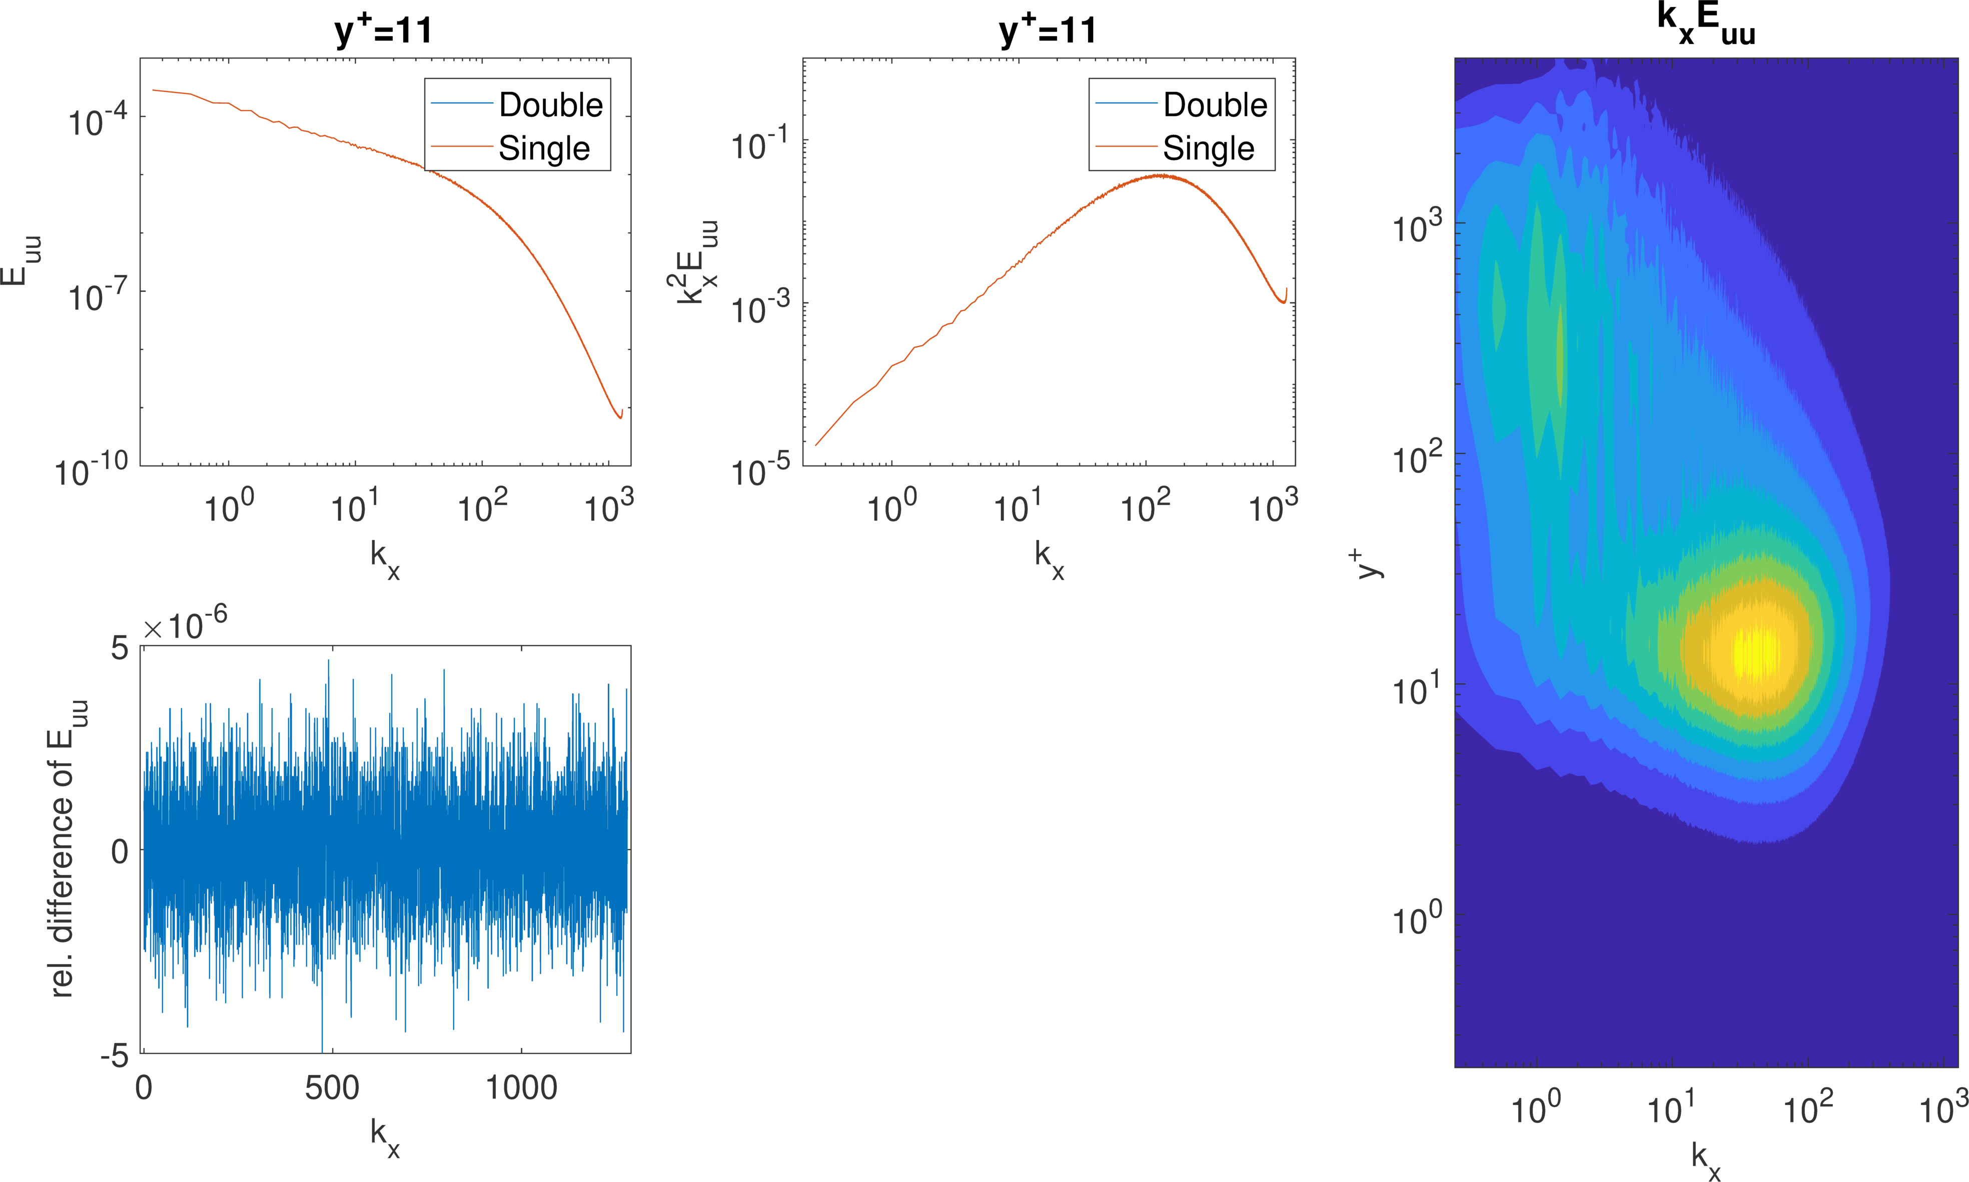b*

Figure 1. (Left) relative error of ${E_{uu}}_{re}={E_{uu}}_{s}-{E_{uu}}_{d}$ (**Streamwise** direction). (Top right) relative error of ${E_{uu}}_{re}={E_{uu}}_{s}-{E_{uu}}_{d}$ at $y^{+}=1000$ ($y=-0.8$). (Bottom right) relative error of ${E_{uu}}_{re}={E_{uu}}_{s}-{E_{uu}}_{d}$ at $y^{+}=5200$ ($y=0$).

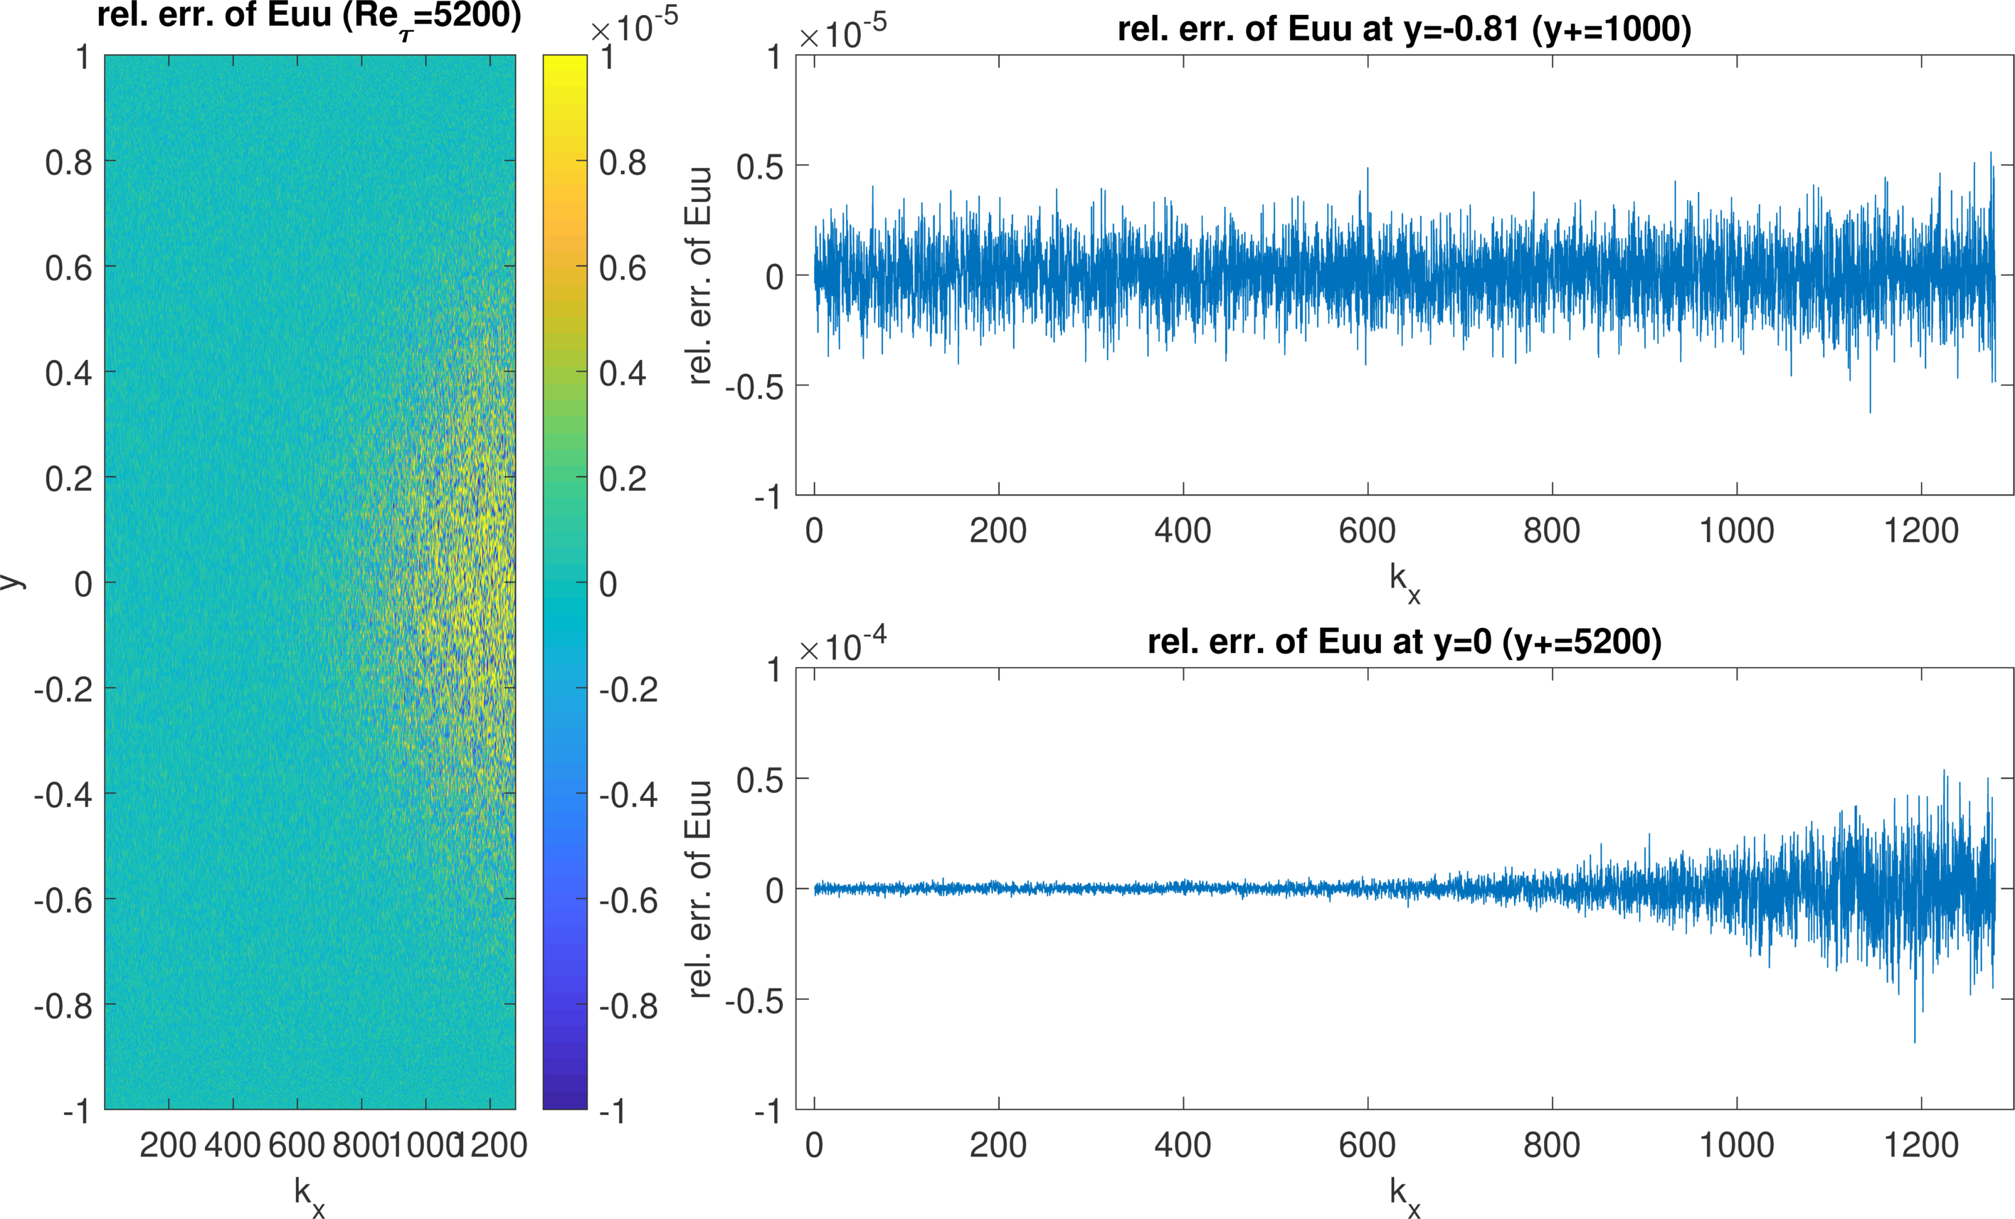

Figure 2. (Left) relative error of ${E_{uu}}_{re}={E_{uu}}_{s}-{E_{uu}}_{d}$ (**Spanwise** direction). (Top right) relative error of ${E_{uu}}_{re}={E_{uu}}_{s}-{E_{uu}}_{d}$ at $y^{+}=1000$ ($y=-0.8$). (Bottom right) relative error of ${E_{uu}}_{re}={E_{uu}}_{s}-{E_{uu}}_{d}$ at $y^{+}=5200$ ($y=0$).

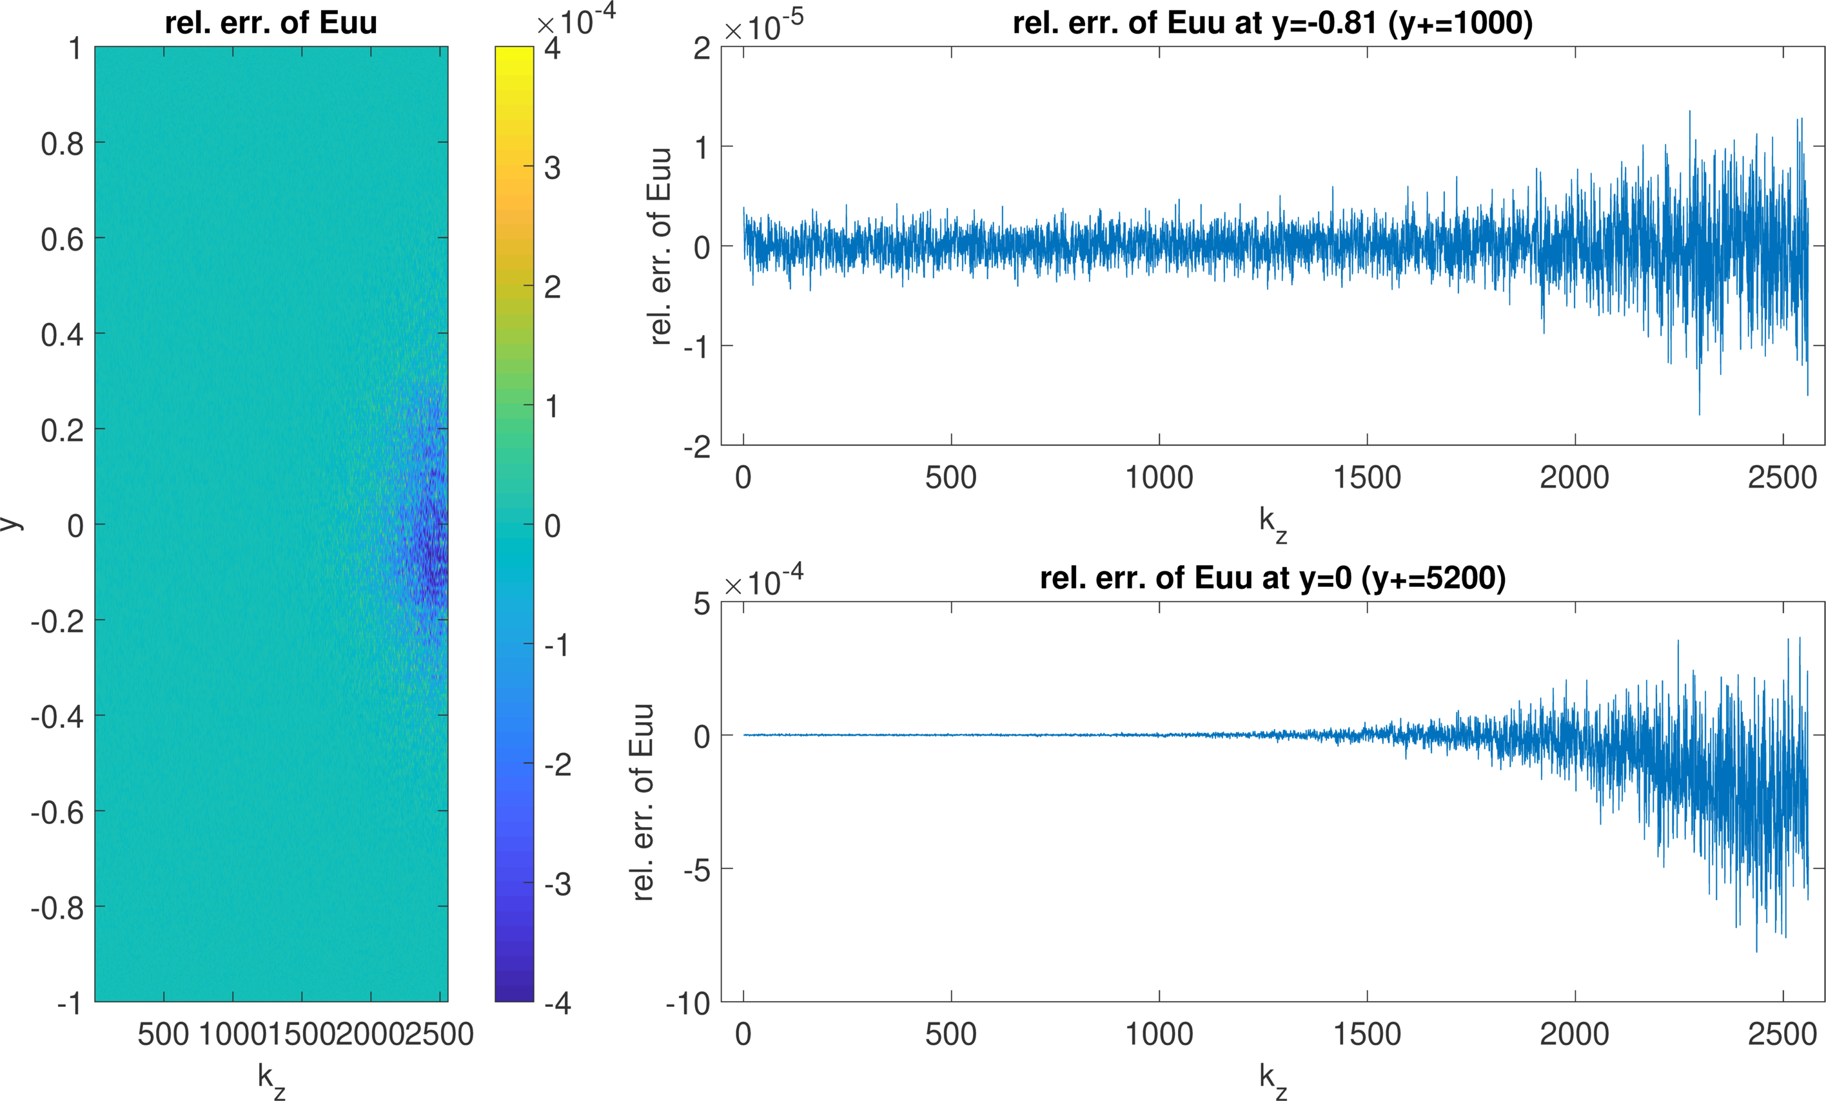

Figure 3*.* **Maximum error** of first and second derivatives at different wall-normal height.Maximum error $f_{e}\left(y\right)=\max_{fix y}\left|f_{s}(x,y,z)-f_{d}(x,y,z)\right|$ is the maximum of $\left|f_{s}(x,y,z)-f_{d}(x,y,z)\right|$ over a wall-parallel plane. The error $f_{e}$ is a function of $y$.5000 $(x,z)$ points are randomly selected.

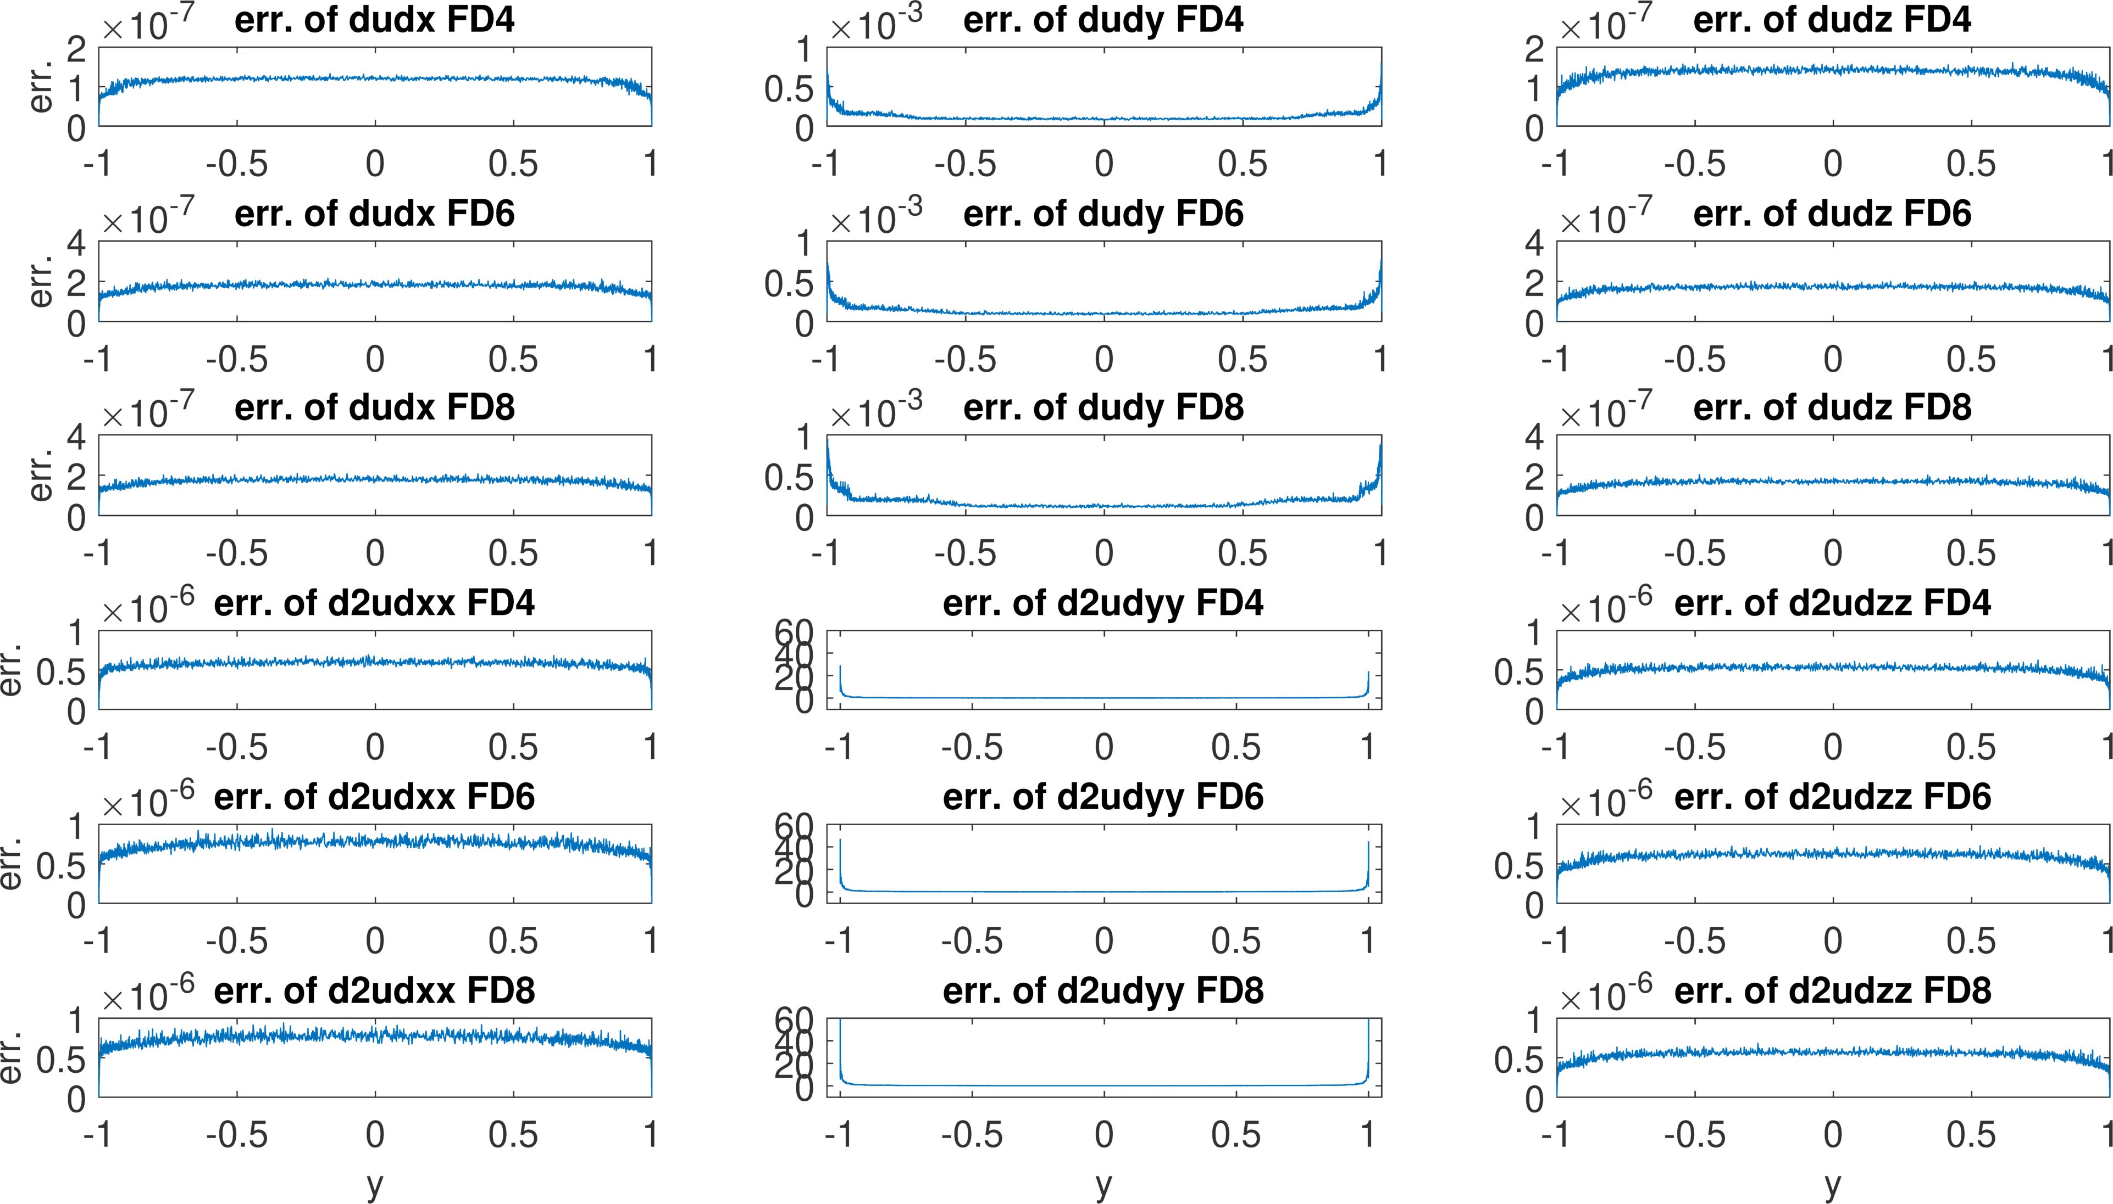

Figure 4*.* **Maximum relativeerror** of first and second derivatives at different wall-normal height. Maximum relative error $f_{re}\left(y\right)=$ ${\max_{fix y}\left|f_{s}(x,y,z)-f_{d}(x,y,z)\right|}/{{〈\left|f_{d}\left(x,y,z\right)\right|〉}_{fix y}}$ $={f_{e}\left(y\right)}/{{〈\left|f_{d}\left(x,y,z\right)\right|〉}_{fix y}}$, where ${〈\left|f_{d}\left(x,y,z\right)\right|〉}_{fix y}$ is the average of $\left|f_{d}(x,y,z)\right|$ over a wall-parallel plane. The relative error $f_{re}$ is a function of $y$.5000 $(x,z)$ points are randomly selected.

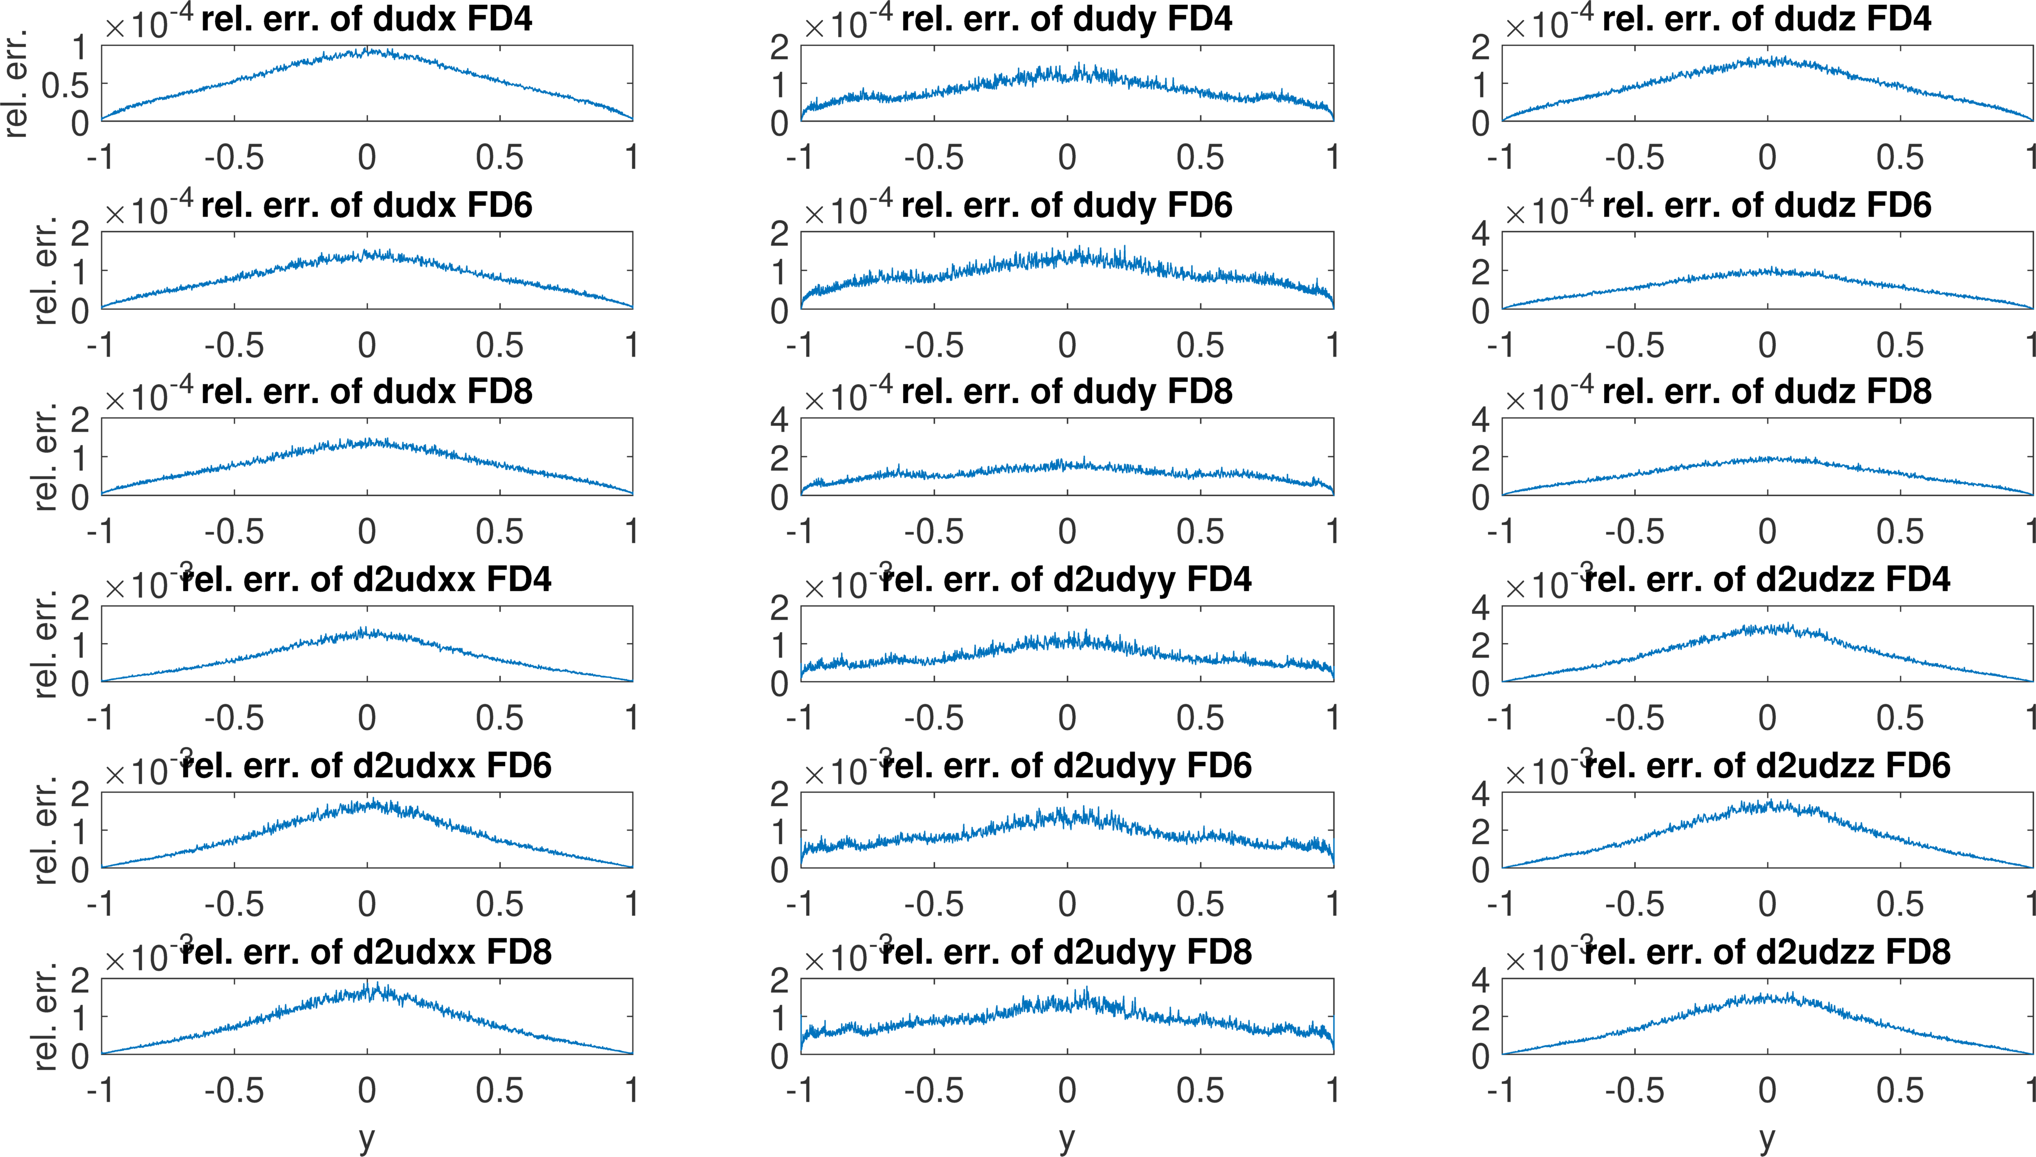

Figure 5*.* **RMS of error** of the continuity condition at different wall-normal height. Let $Div=\frac{∂u}{∂x}+\frac{∂v}{∂y}+\frac{∂w}{∂z}$, and $D=\sqrt{{<{\frac{∂u}{∂x}}^{2}+{\frac{∂v}{∂y}}^{2}+{\frac{∂w}{∂z}}^{2}>}/3}$, where $<⋅>$ is the average over a wall-parallel plane. The RMS of error is defined as $E={\sqrt{<Div^{2}>}}/D$, and thus is a function of $y$. (Top row) $E_{d}$, RMS of error calculated using double precision. (Middle row) $E_{s}$, RMS of error calculated using single precision. (Bottom row) $E_{d}-E_{s}$. 5000 $(x,z)$ points are randomly selected.

